**Circuit Diagram :**

Simulation Profile : 1

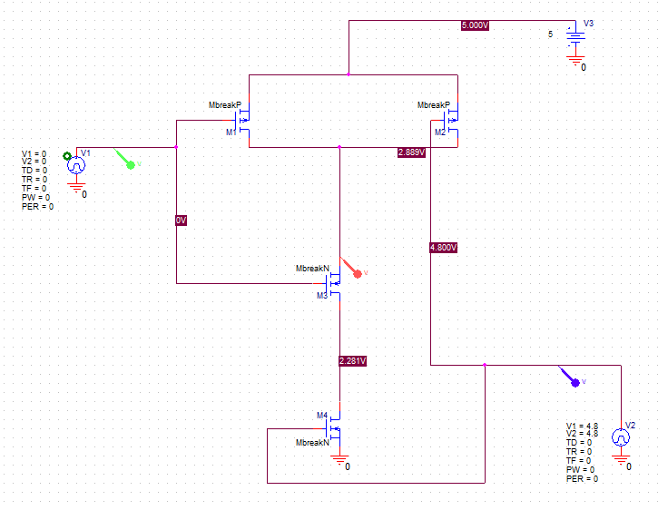

**Figure :** Circuit Diagram.

**Simulation Outcome :**

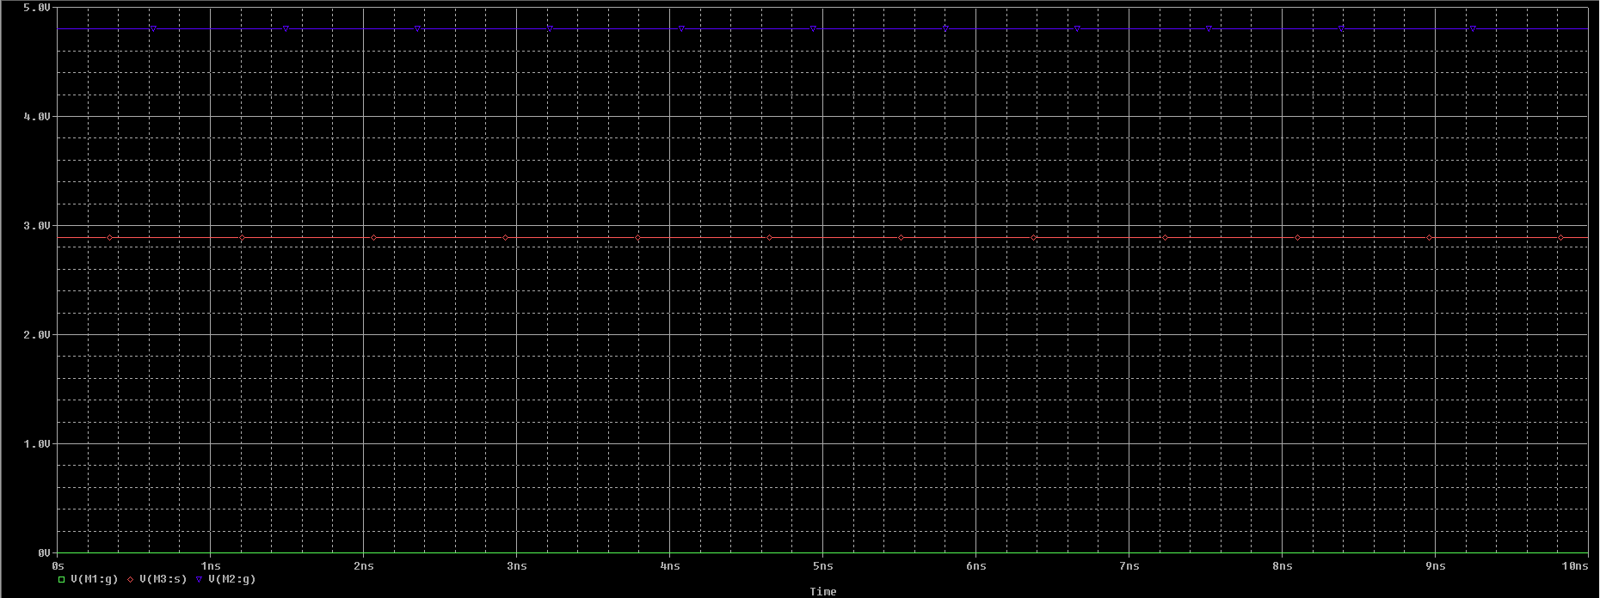

**Figure :** Simulation outcome.

**Circuit Diagram :**

Simulation Profile : 2

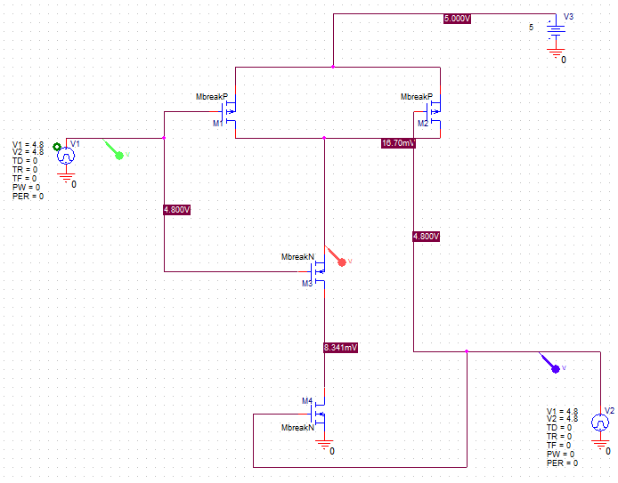

**Figure :** Circuit Diagram.

**Simulation Outcome :**

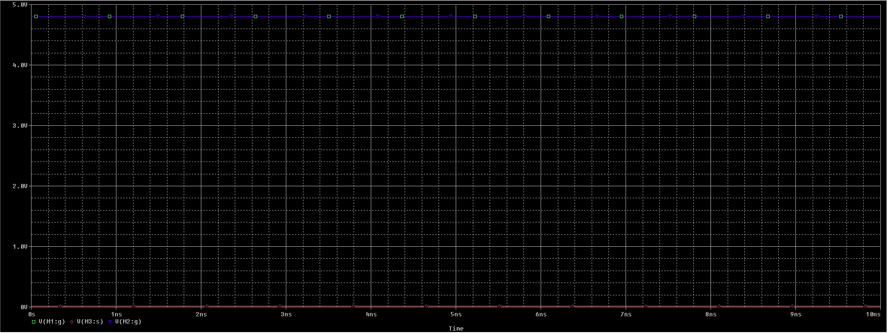

**Figure :** Simulation outcome.

**NOR Gate :**

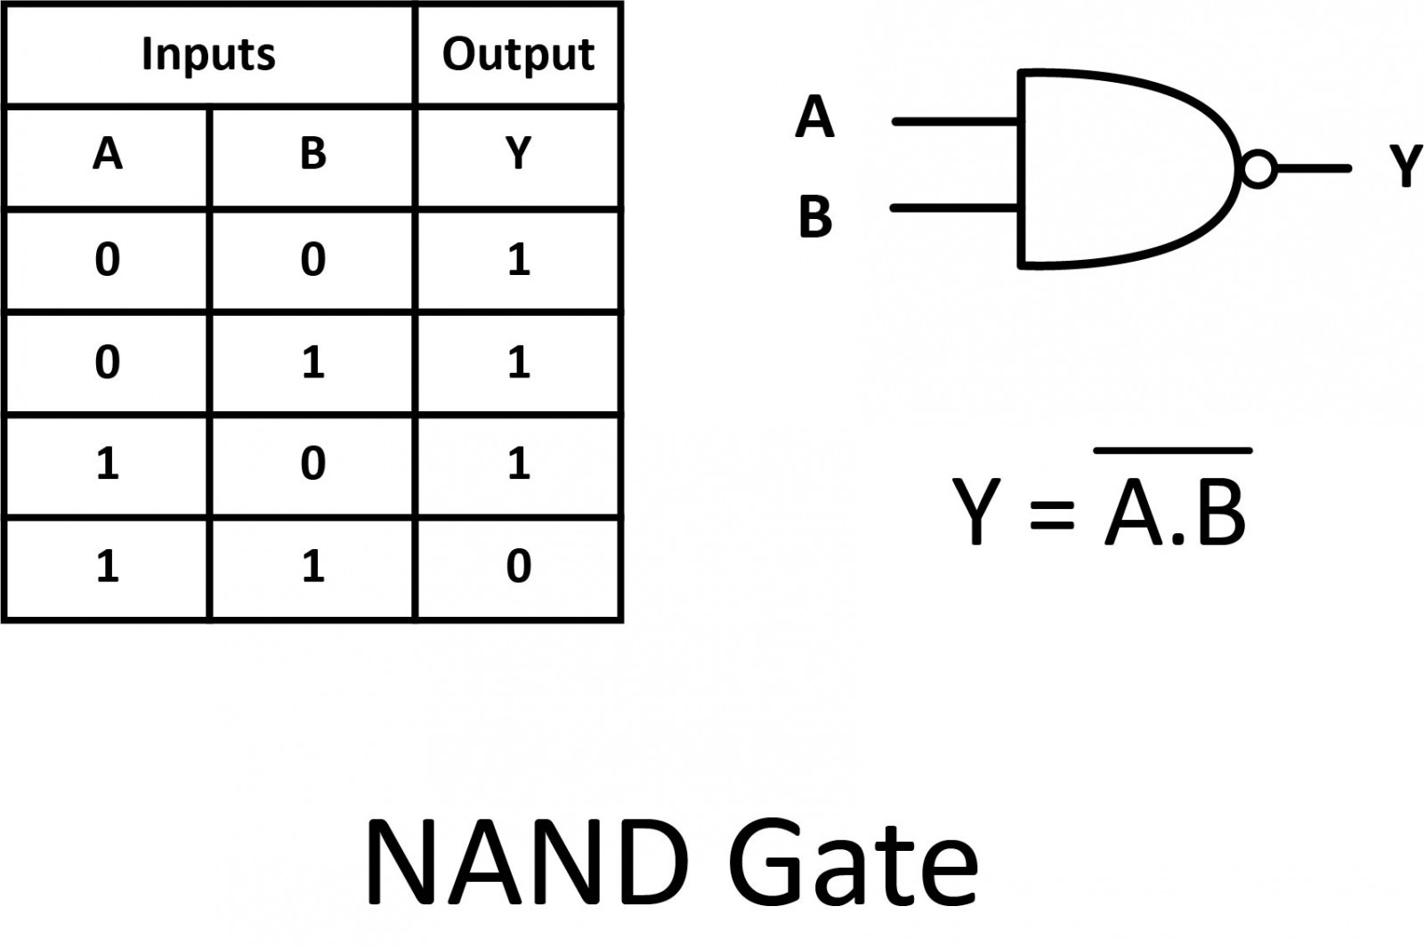

**Simulation :**

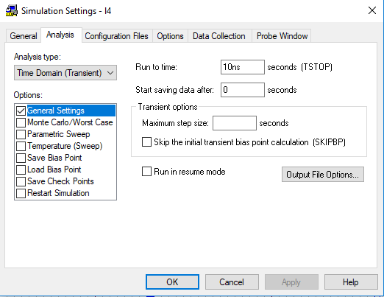

**Figure :** Simulation profile setting.